# AMAZON ELASTIC COMPUTE CLOUD (EC2)

To install and access Windows on an **AWS EC2 instance** using **RDP (Remote Desktop Protocol)**, follow these steps:

**To Launch EC2 Instance**

Compute 🡪 EC2 🡪 Instance 🡪 Launch Instance 🡪 Name 🡪AMS’S

**[ Microsoft windows server 2025 base ]** 🡪 Instance **type:** t3.micro (2 CPU &

1GB RAM) 🡪 Key pair 🡪 Name 🡪 **RSA**  🡪  **.Pem (open ssh )** 🡪 Save

**Create an security group**

Security 🡪 Create Security Group 🡪 Name 🡪 Description 🡪 **Inbound** 🡪

**Add Rule (RDP 3389**) , **Anywhere (IPV4)** 🡪 Create Security Group

Under network setting 🡪 Existing Security Group 🡪 Select the security group

🡪 Storage **{8GB Linux}** 🡪 Launch Instance

**Connect to EC2 instance (windows)**

Connect 🡪 **RDP client** 🡪 RDP file 🡪 Password (**Get password**) 🡪 upload keypair 🡪 **.pem key (private key) decrypt** to get the password 🡪 launch instance

# STEP 1: Get Windows Administrator Password

# After the instance starts, go to EC2 Dashboard → Instances.

# Select your instance and click Connect.

# STEP 2: Click on RDP Client

# Click on get password

# Upload private key or keypair

# 

# 

# 

# STEP 3: Connect to Windows EC2 via RDP

# Open Remote Desktop Connection (RDP) on your local PC

# Enter the Public IP of your EC2 instance.

# Login with: Username: Administrator and Password: (from Step 2)

# 

# C:\Users\Deepak\Downloads\WhatsApp Image 2025-03-11 at 23.13.10_b8ad3dc4.jpg

**Creating AMI Image and Hosting Httpd server**

**Step1:** EC2 Instance Details **(Manually Installation on Launch)**

* Open AWS Management Console → Go to EC2 Dashboard.
* Click on **Instances** and find your running instance.
* Note down the **Public IPv4** address or Public DNS.
* Make sure **port 22 (SSH), HTTPS 443, HTTP 80** is open in your security group.

**Step2:** Open command Prompt through keypair locations

1. Connect to EC2 Instance using SSH

**ssh -i "your-keypair.pem" ec2-user@public-ip-address**

1. To confirm SSH connection type **yes to continue**

# 

**Step 3:** To create an directory 🡪 mkdir dir1

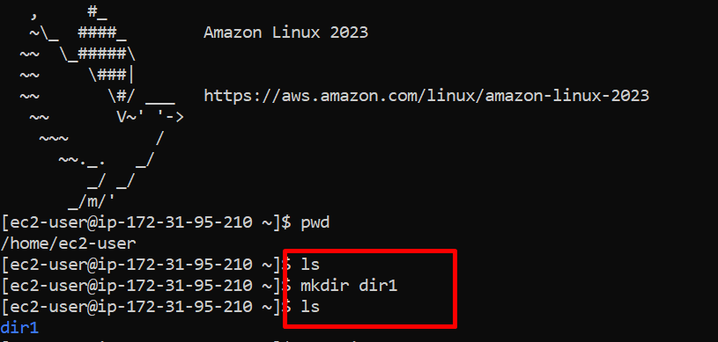

**Step 4:** To create java file inside the dir1 🡪 nano Test.java

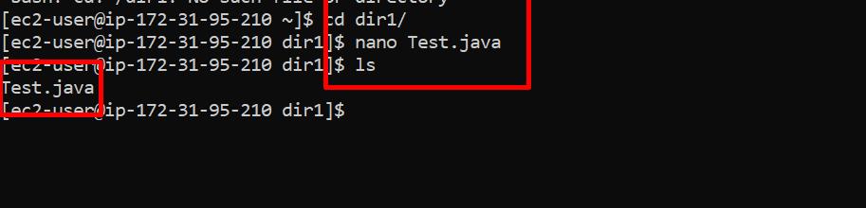

**Step 5:** To switch to the root user 🡪 sudo su

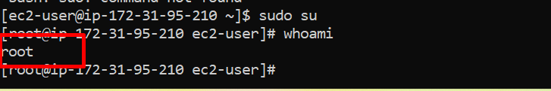

**Step 6:** To install git 🡪 yum install git -y and to check version git –version

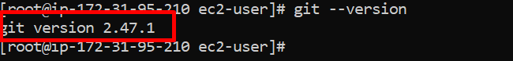

**Step 7:** To install java 🡪 yum install java-17 -y and to check version java –version

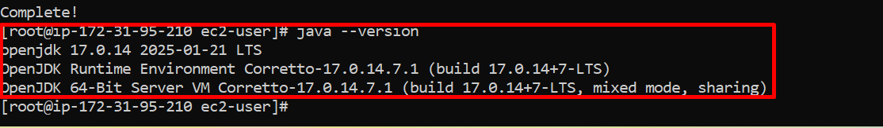

**Step 8:** To create hello world program in java 🡪 nano Test.java , to run java Test.java

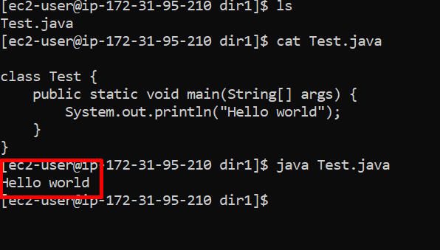

**Step 9:** Command to install httpd 🡪 yum install httpd -y

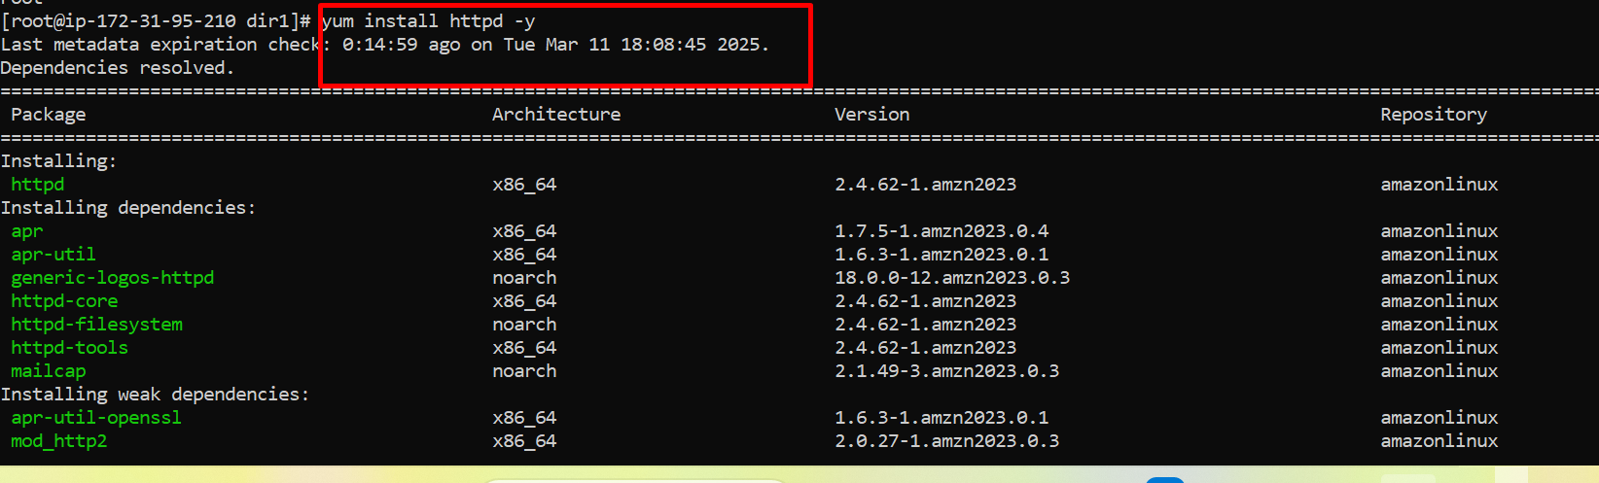

**Step 10:** Command to check the status of httpd 🡪 systemctl status httpd

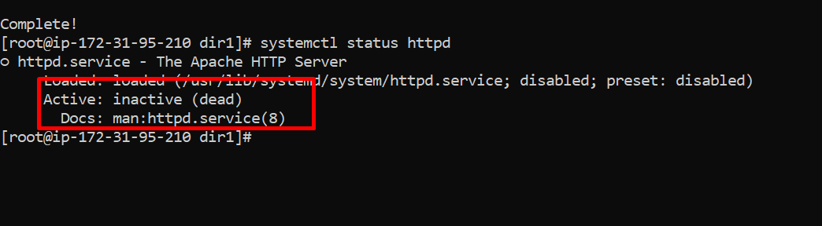

**Step11:** Command to enable the httpd 🡪 systemctl **enable httpd**

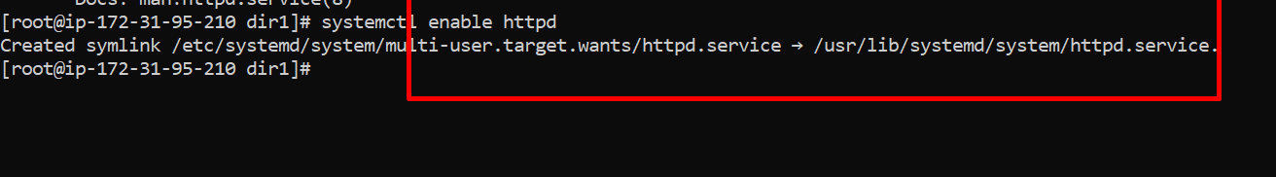

**Step12:** Command to start the httpd 🡪 systemctl **start httpd**

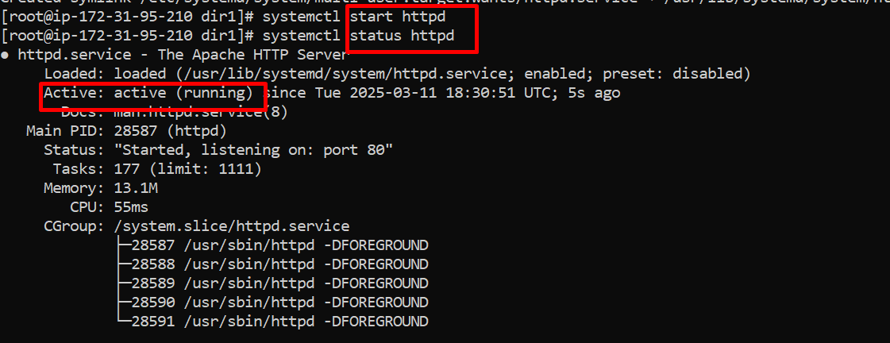

**Step13:** To print message in html content **echo "<h1> Hello everyone </h1>" > /var/www/html/index.html**

* echo "<h1> Hello everyone </h1>" → Outputs the HTML content
* **> →** Redirects the output to the file /var/www/html/index.html.
* If /var/www/html/index.html exists, it will be **overwritten.**



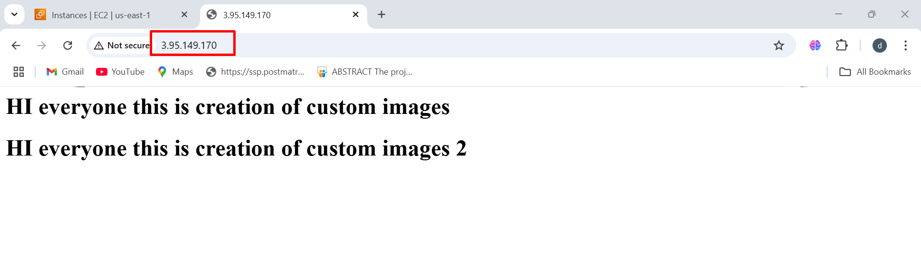

**Create an AMI from an EC2 Instance**

**To Create Image**

Instance 🡪 Select Instance 🡪 Actions 🡪 Images & Templates 🡪 Create

**Images**  🡪 Name & Description 🡪 Create image

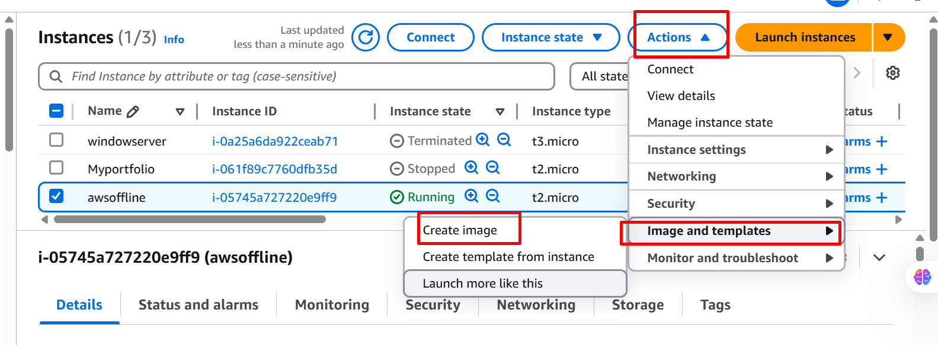

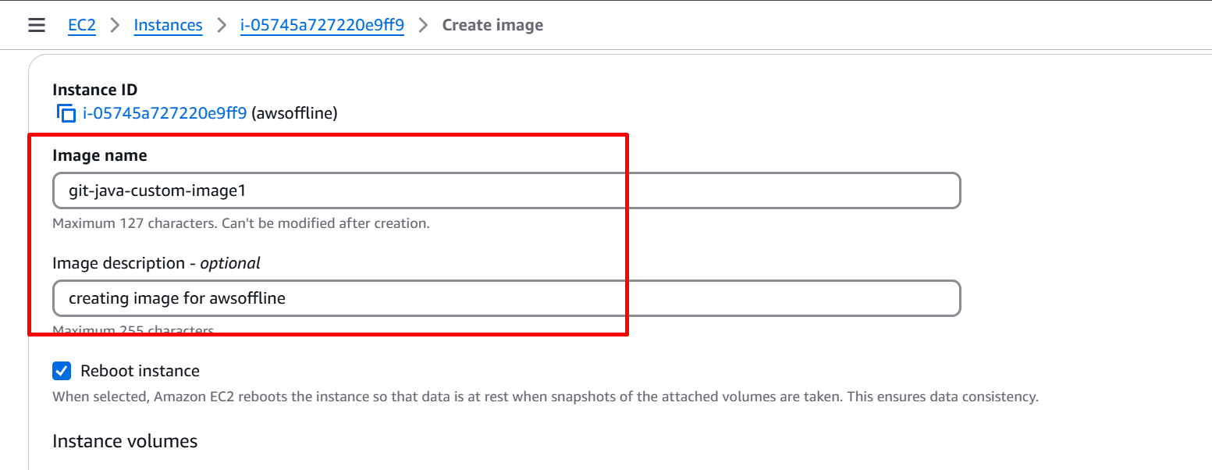

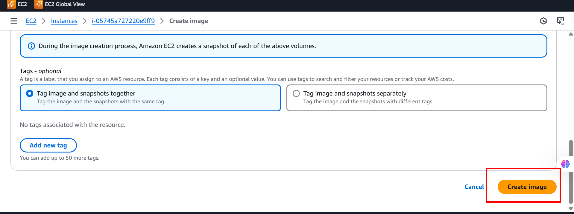

**To Launch Custom Image AMI**

Compute 🡪 Instance 🡪 Launch Instance 🡪 Name 🡪 My AMS’S

**[ Owned by me ]** 🡪 Instance **type:** t2.micro (1 CPU & 1GB RAM) 🡪 Key pair

🡪 Security group 🡪 8gb 🡪 Launch

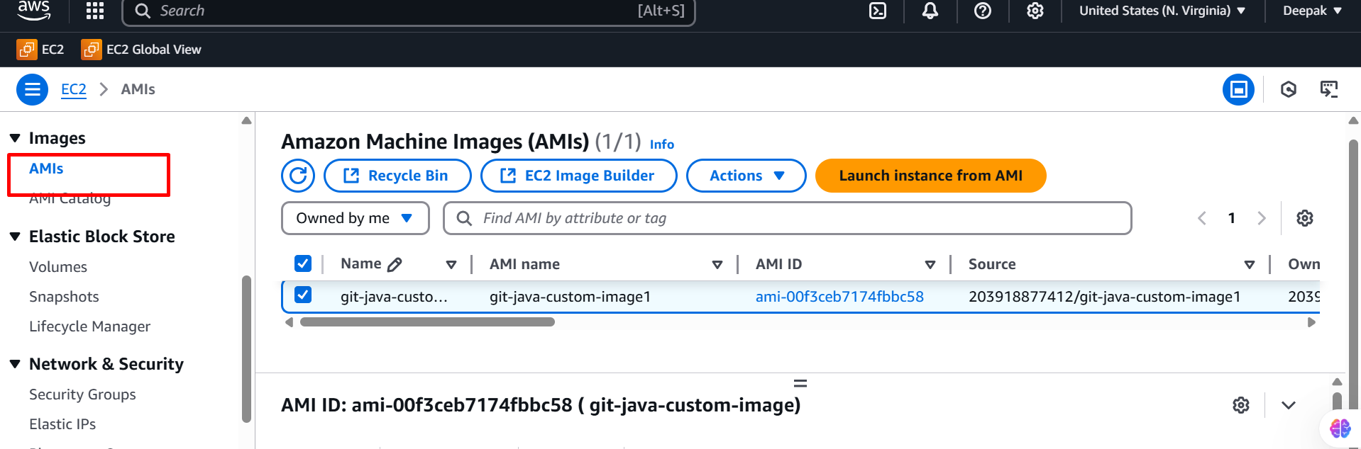

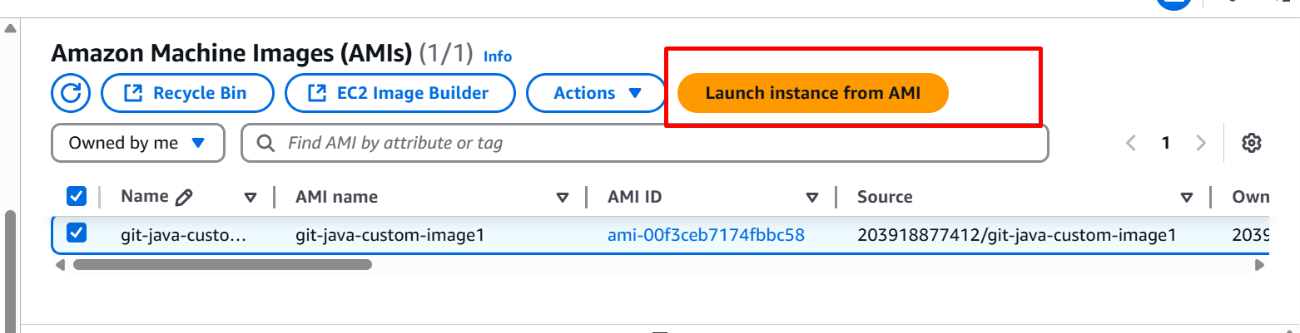

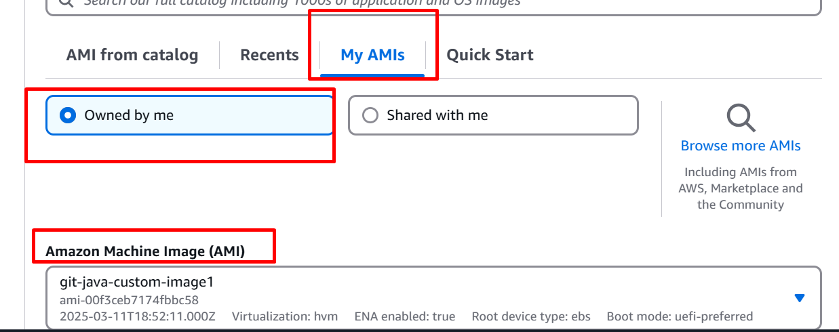

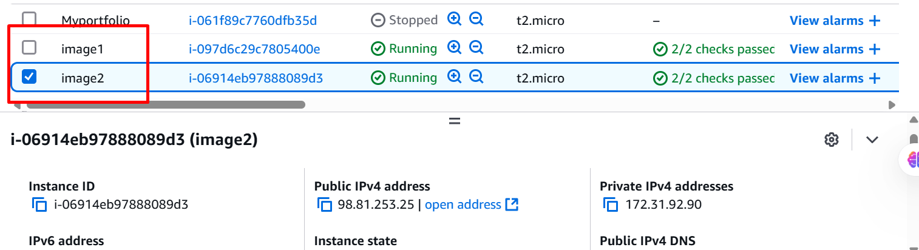

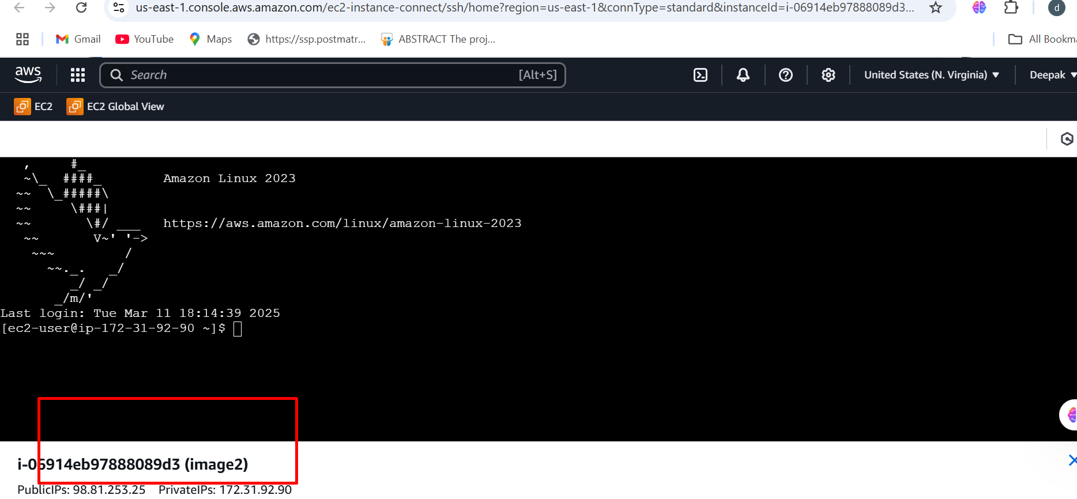

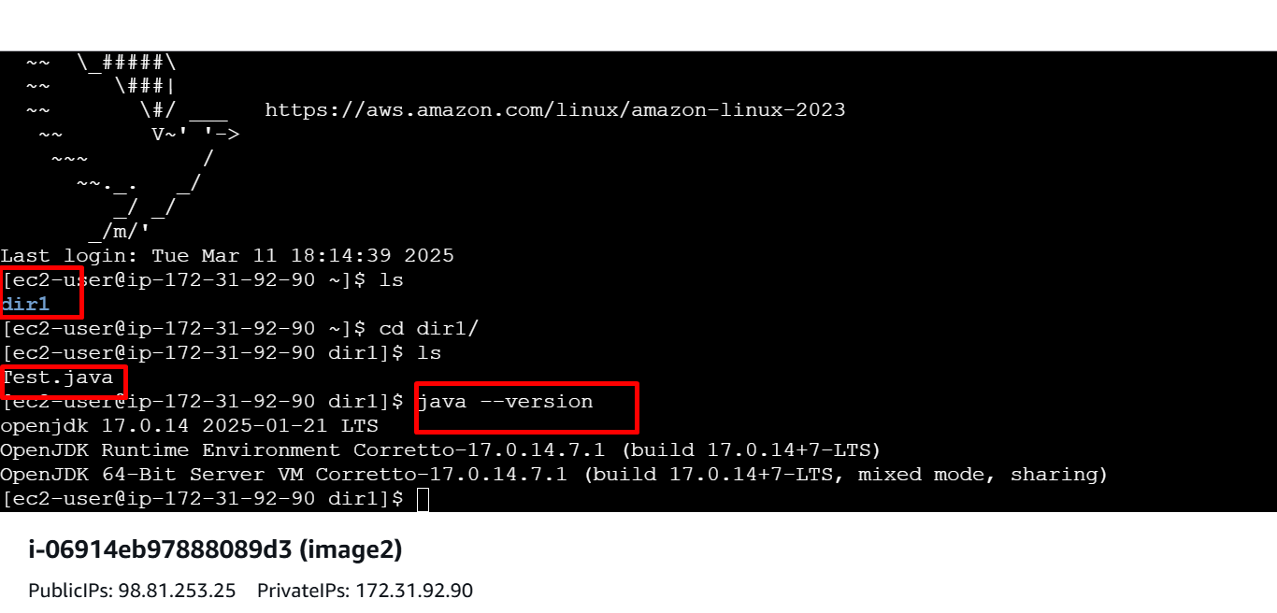

**Httpd server hosted in image2**

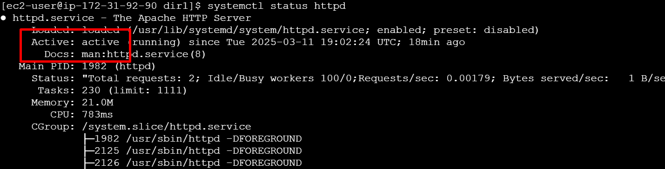

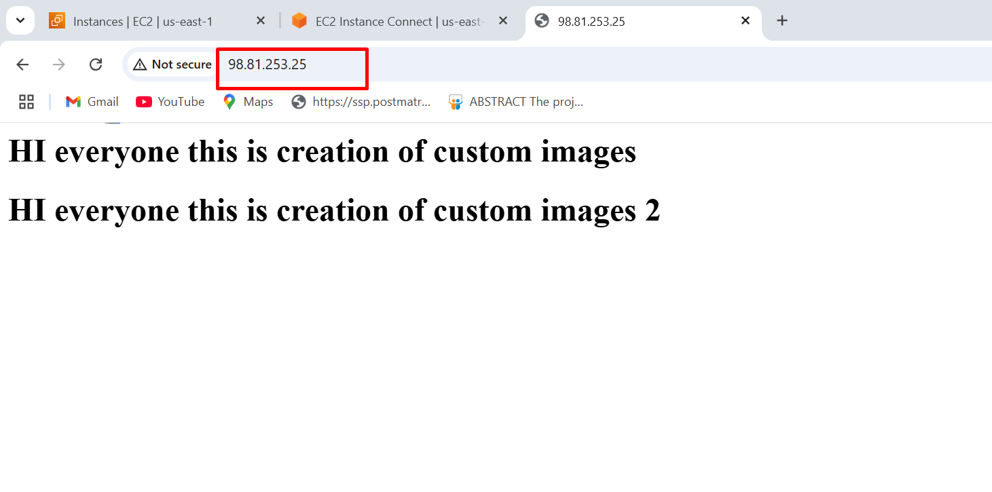

**To share AMI’S to another Account**

AMI 🡪 Actions 🡪 Edit AMI Permission 🡪 Shared a/c 🡪 Add a/c ID

🡪 Save

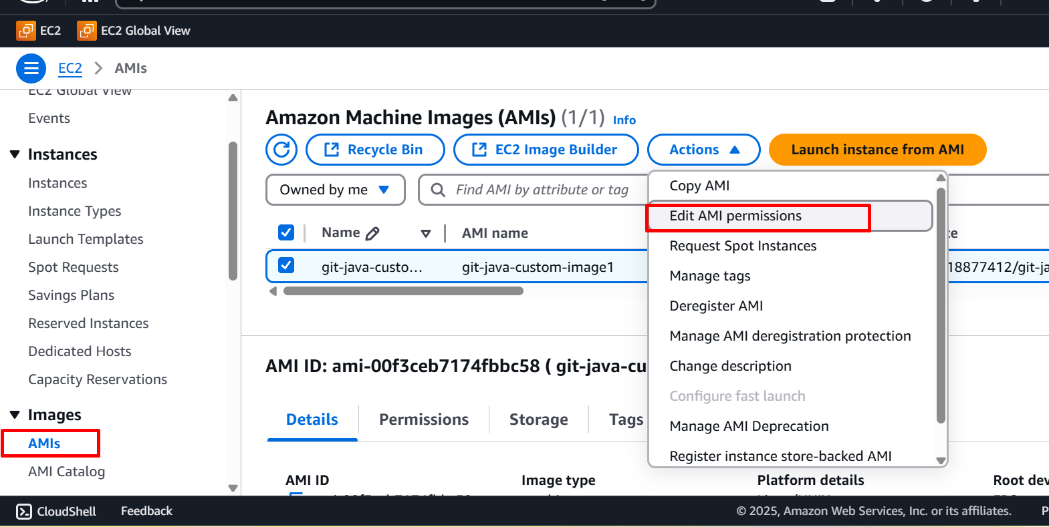

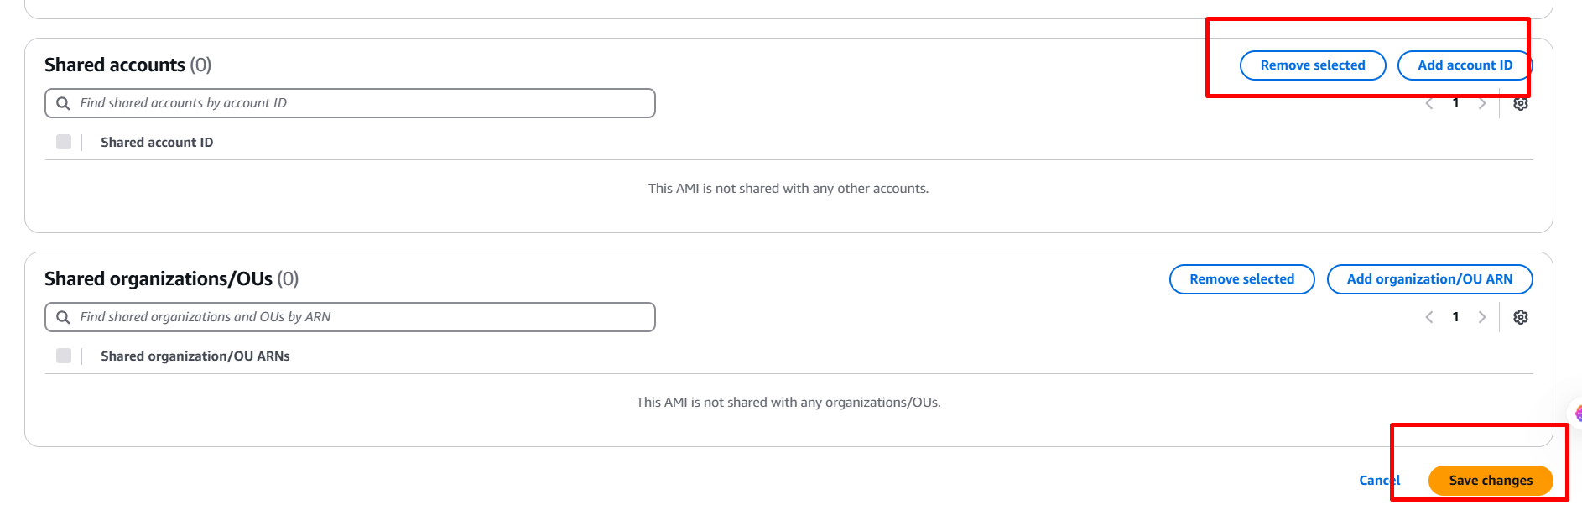

**To stop AMI images**

Deregister the AMI 🡪 Delete Snapshot 🡪 Terminate all EC2 instances

